# CS 255 System Design Document Template

## UML Diagrams

### UML Use Case Diagram

### 

### UML Activity Diagrams

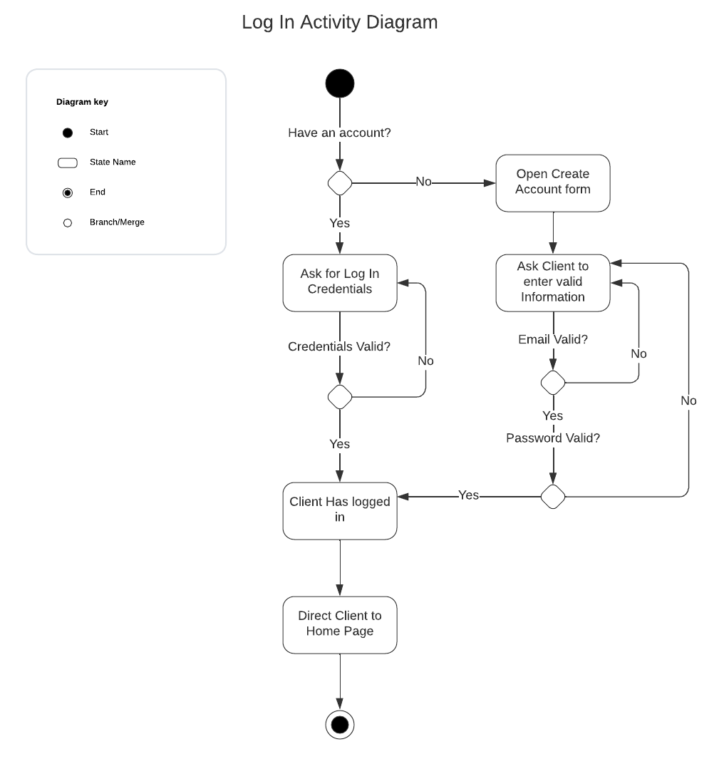

### UML Sequence Diagram

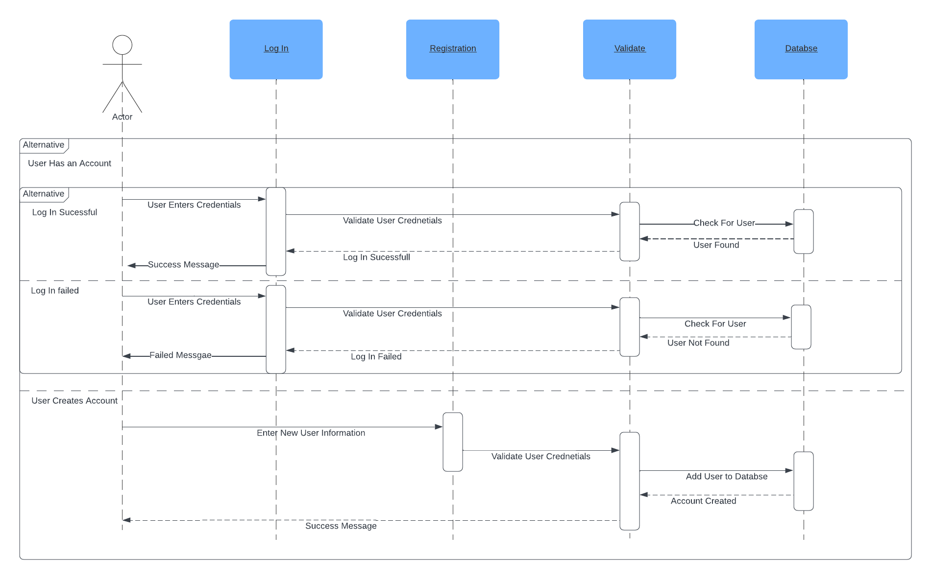

### UML Class Diagram

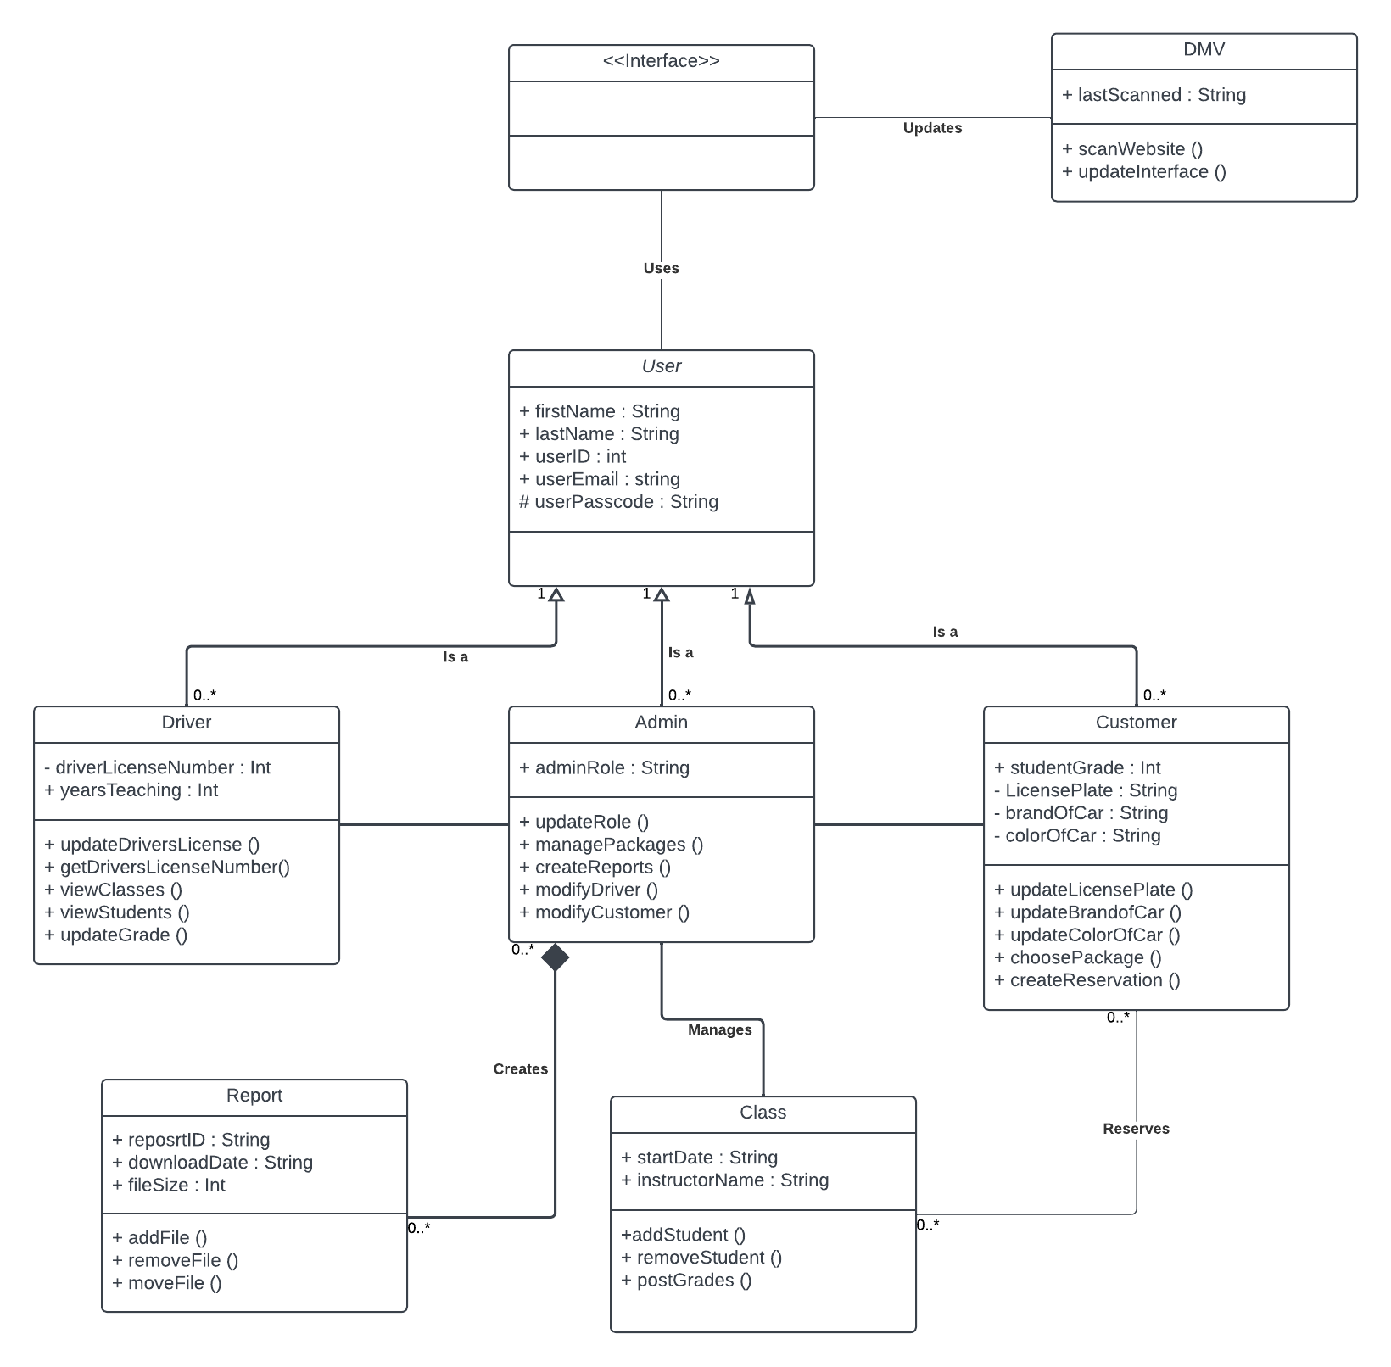

## Technical Requirements

When thinking about the technical requirements we will need to get this DriverPass system operational, there are many options for tools and technologies. While we could have DriverPass host their own servers, it would be easier and less costly to just host the website and databases via a cloud computing service. If we were to make our own servers, we would need to invest in high power processors, a large amount of RAM and hard storage as well and upgraded networking abilities to keep the servers running smoothly. We can instead pass this responsibility over to a cloud system and they can host the site. This means that the only real hardware we need is within the computers we will use to access the system once it is built. For this any up-to-date computer or mobile device will work. Choosing the software is where there are many more options to choose from. We will need to choose software for the web server, database, the OS it will use to run off, the method of version control, backups and recovery, and networking. There are various options for each and many combinations of each will work. The software chosen can help us establish how the system design and infrastructure will be set up. Things we need to consider for this system are efficiently controlling resources, storing, and managing data, balancing servers, security measures, and how we will go about backing up and recovering the system.